**Use of Cloth Face Coverings to Help Slow the Spread of COVID-19**

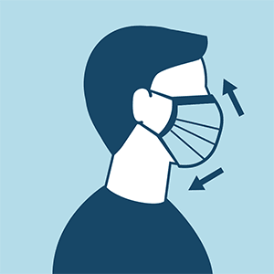

Cloth face coverings should—

* fit snugly but comfortably against the side of the face
* be secured with ties or ear loops
* include multiple layers of fabric
* allow for breathing without restriction
* be able to be laundered and machine dried without damage or change to shape

**CDC on Homemade Cloth Face Coverings**

CDC recommends wearing cloth face coverings in public settings where other social distancing measures are difficult to maintain (e.g., grocery stores and pharmacies), **especially** in areas of significant community-based transmission.

CDC also advises the use of simple cloth face coverings to slow the spread of the virus and help people who may have the virus and do not know it from transmitting it to others.  Cloth face coverings fashioned from household items or made at home from common materials at low cost can be used as an additional, voluntary public health measure.

Cloth face coverings should not be placed on young children under age 2, anyone who has trouble breathing, or is unconscious, incapacitated or otherwise unable to remove the mask without assistance.

The cloth face coverings recommended are not surgical masks or N-95 respirators.  Those are critical supplies that must continue to be reserved for healthcare workers and other medical first responders, as recommended by current CDC guidance.

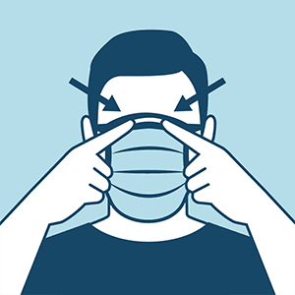

**Should cloth face coverings be washed or otherwise cleaned regularly? How regularly?**

Yes. They should be routinely washed depending on the frequency of use.

**How does one safely sterilize/clean a cloth face covering?**

A washing machine should suffice in properly washing a face covering.

**How does one safely remove a used cloth face covering?**

Individuals should be careful not to touch their eyes, nose, and mouth when removing their face covering and wash hands immediately after removing.